臭氧发生器
使用说明书
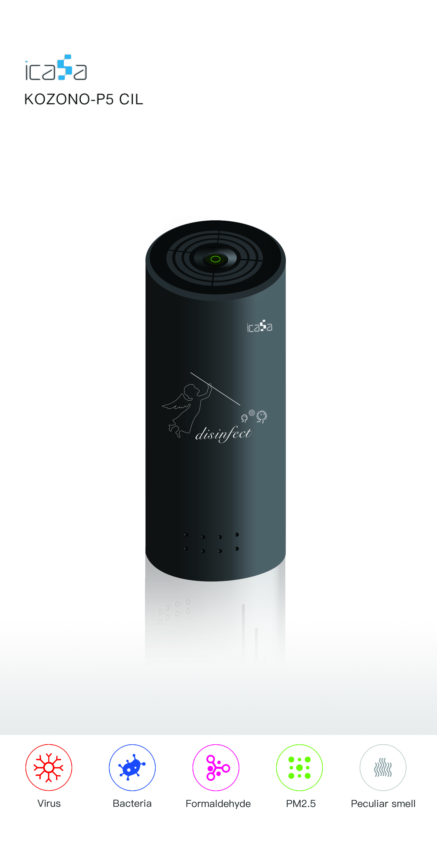

博耳智能

尊敬的用户：
非常感谢您选用我公司生产的臭氧发生器系列产品。在您使用本产品之前，请仔细阅读本使用说明书。

本说明书中描述的产品只适合经过培训合格的工作人员使用。
本产品的调整、修理和维护必须由厂商指定的授权人员进行。
为了正确、安全地使用本产品，请您务必按本说明书地描述进行操作。
我们建议保持产品卷标完整。
我们建议不要拆卸本产品。
我们不对由于使用产品不当造成的损伤或伤害承担任何责任。
我们改进产品性能或修改使用说明书内容时，恕不另行通知。
如果需要最新的产品或资料，请及时与经销商或我公司联系，我们会尽量提供最新产品信息和资料，如果发现说明书中出现任何错误，请及时和我们取得联系，我们表示非常感谢。
未经我公司许可，严禁拷贝和仿制本说明书的全部或部分内容，违者必究。
本说明书内容包括臭氧臭氧发生器构造说明、功能介绍、接线方式、型号介绍、应用范围、操作说明及注意事项等内容，使用前请详细阅读。

产品概述
臭氧发生器是用于制取臭氧气体（O₃）的装置。臭氧易于分解无法储存，需现场制取现场使用，所以凡是能用到臭氧的场所均需使用臭氧发生器。臭氧发生器在饮用水，污水，工业氧化，食品加工和保鲜，医药合成，空间灭菌等领域广泛应用。 臭氧发生器产生的臭氧气体可以直接利用，也可以通过混合装置和液体混合参与反应。
利用高压电离使空气中的氧气分解聚合为臭氧，臭氧形成的过程是氧的同素异形转变过程。臭氧的不稳定性使其很难实现瓶装贮存 ，一般只能利用臭氧发生器现场生产，随产随用。
臭氧为混合气体，其浓度通常按质量比或体积比来表示。质量比是指单位体积内混合气体中含有多少质量的臭氧，常用单位mg/L、mg/m³或g/m³等表示。体积比是指单位体积内臭氧所占的体积含量或百分比含量，卫生行业常用ppm表示臭氧浓度，即每立方臭氧混合气体中臭氧占该体积的百万分之一为1ppm。臭氧浓度是衡量臭氧发生器技术含量和性能的重要指标。同等的工况条件下臭氧输出浓度越高其品质度就越高。

产品型号
KOZONO-P5 CIL
K公司代号
OZONO 臭氧系列产品
P5 表示1小时制氧量为5g
CIL是圆柱形

产品结构
产品主体是一个柱体结构，外壳为6063铝管状壳体（可以有效防止臭氧的侵蚀，保证产品寿命）。管体内上下分层安装了四个功能模块，分别是：静音风机、臭氧发生模块、定时控制电路、控制开关按键。风机是一款静音优质风机；控制开关按键可以控制设备的开关，定时开关设定工作的时间长度15min；带远程控制可通过app智能的控制设备开启的时间。

WIFI配对使用说明
- 首先下载APP爱家仕。
- 之后点击“+”新增设备。
- 找到空气净化→臭氧设备。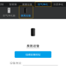
- 用针戳下臭氧机器上的复位孔，灯光闪烁表示进入状态，接受配对。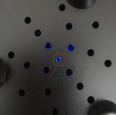
- 填写信息，进行配对，直至灯光不闪表示配对成功。

使用方法
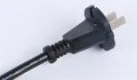
图1
图2

- 将图1所示的插头接通220v电源。
- 按下图2所示的定时按钮，臭氧开始工作15分钟，15分钟后如需再启动，只需要再次按下定时按钮。

注意事项
1.使用注意事项：
臭氧发生器安装人员必须要经过技术培训才能开机维修；
严禁工作人员在浓度较高的臭氧环境中上班和工作；
切记设备保养或维修时切断电源和把臭氧泄气的状态下进行，能够很好的确保人员安全维修；
如有异常，请立即断电或者通知专业的人员进行检修。
禁止安装在氨气易泄露或有发生爆炸危险的危险区；
如发生臭氧泄漏的情况时，需要第一时间关闭臭氧发生器，并开启通风设备进行通风处理后，即时退出臭氧发生器使用空间，等空间残余臭氧降至安全范围再进入。
2.维修注意事项：
臭氧发生器出现异常时，就及时排查故障原因，如果确认故障发生在臭氧发生器内部，如电源、变压器、放电单元时，我们不建议用户自行修理这些故障点。请及时通知我公司，我们会委派专业维修人员前往处理。
我们不建议用户自行拆卸臭氧发生器本体和电源控制系统，即使用是保修期外，我们仍然坚持这样。

Ozone Generator
Instruction Manual
By BOER

Dear user,
Thank you very much for choosing Boer Ozone Generator. Please read this manual carefully before you use this product.
The products described in this manual are only suitable for the use of trained and qualified personnel.
The adjustment, repair and maintenance of this product must be carried out by authorized personnel designated by the manufacturer.
In order to use the product correctly and safely, please operate according to the description in this manual.
We suggest to keep the product label intact.
We recommend that you do not disassemble this product. We are not responsible for any damage or injury caused by improper use of the product.
We are not informed when we improve the product performance or modify the contents of the instruction manual.
If you need the latest product or information, please contact the dealer or our company in time. We will try our best to provide the latest product information.
Without the permission of our company, it is strictly prohibited to copy all or part of the contents of this manual. Any violator shall be punished.
This manual includes the construction description, function introduction, wiring mode, model introduction, application scope, operation instructions and precautions of Ozone Generator. Please read them carefully before use.

Product Overview
Boer Ozone Generator is a device for producing ozone gas (O₃). Ozone is easy to decompose and cannot be stored, so it needs to be prepared on site for use. Therefore, Ozone Generators are required in all places where ozone can be used. Ozone generator is widely used in drinking water, sewage, industrial oxidation, food processing and preservation, pharmaceutical synthesis, space sterilization and other fields. The ozone gas produced by the Ozone Generator can be used directly, or can be mixed with liquid through the mixing device to participate in the reaction.
Oxygen in the air is decomposed and polymerized into ozone by high pressure ionization. The process of ozone formation is the process of oxygen allotrope transformation. The instability of ozone makes it difficult to realize the bottled storage. Generally, the Ozone Generator can only be used for production on the spot and can be used as soon as it is produced.
Ozone is a mixed gas, its concentration is usually expressed by mass ratio or volume ratio. Mass ratio refers to the quantity of ozone contained in the mixed gas per unit volume, which is usually expressed in mg / L, mg / m³ or g / m³. Volume ratio refers to the volume content or percentage content of ozone in a unit volume. In the health industry, ppm is commonly used to express the ozone concentration, that is, one millionth of the volume of ozone in each cubic ozone mixture is 1ppm. Ozone concentration is an important index to measure the technical content and performance of ozone generator. Under the same operating conditions, the higher the ozone output concentration, the higher the quality.
Product Model
KOZONO-P5 CIL
HC : Company Code
OZONO：Ozone series products.
A : Remote APP control / M means : Manual
220 : Working voltage
P5 : 5g of oxygen production per hour
CIL:Cylindrical.

Instructions for wifi pairing
- First download the app icasa。
- Then click “+”add device。
- Find air puricication→Ozone equipment.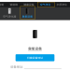
- Poke the reset hole in the ozone machine with a needle，the flashing light indicates entering state，accept pairing.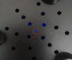
- Fill in the information and match until the lights do not flicker to indicate a successful match.
Product Structure
The main body of the product is a cylinder structure, and the shell is a tubular shell made of 304 stainless steel (stainless steel can effectively prevent ozone erosion and ensure the product life). Four functional modules are installed in the pipe body, which are mute fan, Ozone Generation module, timing control circuit and control switch button. The fan is a quiet high-quality fan, made of ABS environmental protection material (ABS material can also prevent ozone erosion); the control switch button can control the switch of the equipment, and the fixed time switch can set the working time of 15min; with remote control module, the opening time of the equipment can be controlled by APP intelligent control device.

Use Instruction
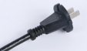
Fig. 1 Fig. 2
Connect the plug (shown in Figure 1) to the 220V power supply.
Press the timing button shown in Figure 2. The ozone generator starts to work for 15 minutes, and if it needs to be started again after 15 minutes, just press the timing button again.

Attention
1. Precautions for Use
The installation personnel of the Ozone Generator must receive technical training before starting up for maintenance;
It is strictly prohibited for staff to work in ozone environment with high concentration;
Remember to cut off the power supply and deflate the ozone when maintaining or repairing the equipment, so as to ensure the safety of personnel;
In case of any abnormality, please immediately cut off the power or inform the professional personnel for maintenance.
It is forbidden to be installed in the hazardous area where ammonia is easy to leak or there is a risk of explosion;
In case of ozone leakage, it is necessary to shut down the Ozone Generator as soon as possible, turn on the ventilation equipment for ventilation treatment, and then immediately exit the ozone generator using space, wait for the residual ozone in the space to fall to the safe range before entering.

2. Maintenance precautions
In case of any abnormality of the Ozone Generator, check the cause of the failure timely. If it is confirmed that the failure occurs inside the Ozone Generator, such as power supply, transformer and discharge unit, we do not recommend you to repair these failure points by yourself. Please inform our company in time, we will appoint professional maintenance personnel to deal with it.
We do not recommend you to dismantle the Ozone Generator body and power control system by yourself. Even after the warranty period, we still insist on this.

After-sale service
Boer will provide free maintenance service for Ozone Generator and supporting equipment within one year and free of cost. However, in case of failure in the following circumstances, we will implement paid service:
★ Damage caused by unauthorized disassembly and maintenance by users
★ Damage caused by the user's failure to install and use in accordance with the requirements of this manual
★ Damage caused by natural disasters
★ Damage caused by fire or external hard damage
★ Damage beyond the warranty per

